**Star Schema Data Warehouse Implementation**

**Objective**

To design and implement a star schema in PostgreSQL that supports analytical queries on Walmart’s weekly sales data. This includes creating normalized dimension tables and a centralized fact table for efficient querying and reporting.

**Dataset Overview**

**Source File:** Walmart_Sales.csv  
**Fields:**

* **Store:** Store ID
* **Date:** Weekly record date
* **Weekly_Sales:** Sales revenue for the week
* **Holiday_Flag:** 1 if holiday week, else 0
* **Temperature:** Average temperature
* **Fuel_Price:** Cost per gallon
* **CPI:** Consumer Price Index
* **Unemployment:** Regional unemployment rate

**Schema Design**

**The star schema consists of the following tables:**

1. Fact Table: fact_weekly_sales  
 - date_key (FK to dim_date)  
 - store_key (FK to dim_store)  
 - weekly_sales  
 - holiday_flag  
 - temperature  
 - fuel_price  
 - cpi  
 - unemployment  
  
2. Dimension Table: dim_date  
 - date_key (Primary Key)  
 - date  
 - week  
 - month  
 - quarter  
 - year  
  
3. Dimension Table: dim_store  
 - store_key (Primary Key)

**Implementation Steps**

**1. Database Creation**

***CREATE DATABASE retail_dw OWNER postgres;***

**2. Schema & Table Setup**

**Tables were created inside the star schema, including a staging table for CSV import:**

***CREATE SCHEMA IF NOT EXISTS star;***

***SET search_path = star;***

**Staging table for raw CSV**

***CREATE TABLE IF NOT EXISTS staging_sales (***

***store INTEGER,***

***date DATE,***

***weekly_sales NUMERIC(14,2),***

***holiday_flag SMALLINT,***

***temperature REAL,***

***fuel_price NUMERIC(6,3),***

***cpi REAL,***

***unemployment REAL***

***);***

**Dimension: Date**

***CREATE TABLE IF NOT EXISTS dim_date (***

***date_key INTEGER PRIMARY KEY, -- YYYYMMDD***

***date DATE NOT NULL,***

***week SMALLINT NOT NULL,***

***month SMALLINT NOT NULL,***

***quarter SMALLINT NOT NULL,***

***year INTEGER NOT NULL***

***);***

**Dimension: Store**

***CREATE TABLE IF NOT EXISTS dim_store (***

***store_key INTEGER PRIMARY***

***);***

**Fact: Weekly Sales**

***CREATE TABLE IF NOT EXISTS fact_weekly_sales (***

***date_key INTEGER NOT NULL***

***REFERENCES dim_date(date_key),***

***store_key INTEGER NOT NULL***

***REFERENCES dim_store(store_key),***

***weekly_sales NUMERIC(14,2) NOT NULL,***

***holiday_flag SMALLINT NOT NULL,***

***temperature REAL,***

***fuel_price NUMERIC(6,3),***

***cpi REAL,***

***unemployment REAL,***

***PRIMARY KEY (date_key, store_key)***

***);***

**3. Data Import Using \copy**

**Used \copy to load local CSV:**

***\copy staging_sales(store, date, weekly_sales, holiday_flag, temperature, fuel_price, cpi, unemployment)***

***FROM 'C:/Users/Manan/Downloads/Walmart_Sales.csv'***

***WITH (FORMAT csv, HEADER true);***

**4. Populating Dimension Tables**

**dim_date:**

***INSERT INTO dim_date(date_key, date, week, month, quarter, year)***

***SELECT***

***EXTRACT(YEAR FROM date)::INT * 10000 +***

***EXTRACT(MONTH FROM date)::INT * 100 +***

***EXTRACT(DAY FROM date)::INT AS date_key,***

***date,***

***TO_CHAR(date, 'IW')::SMALLINT AS week,***

***EXTRACT(MONTH FROM date)::SMALLINT,***

***EXTRACT(QUARTER FROM date)::SMALLINT,***

***EXTRACT(YEAR FROM date)::INT***

***FROM (SELECT DISTINCT date FROM staging_sales) d***

***ON CONFLICT (date_key) DO NOTHING;***

**dim_store:**

***INSERT INTO dim_store(store_key)***

***SELECT DISTINCT store FROM staging_sales***

***ON CONFLICT (store_key) DO NOTHING;***

**5. Populating Fact Table**

***INSERT INTO fact_weekly_sales(date_key, store_key, weekly_sales, holiday_flag, temperature, fuel_price, cpi, unemployment)***

***SELECT***

***EXTRACT(YEAR FROM date)::INT * 10000 +***

***EXTRACT(MONTH FROM date)::INT * 100 +***

***EXTRACT(DAY FROM date)::INT AS date_key,***

***store,***

***weekly_sales,***

***holiday_flag,***

***temperature,***

***fuel_price,***

***cpi,***

***unemployment***

***FROM staging_sales***

***ON CONFLICT (date_key, store_key) DO NOTHING;***

**Validation &Testing**

**Verify Structure of Each Table**

**Check columns and primary keys:**

***\d star.dim_date***

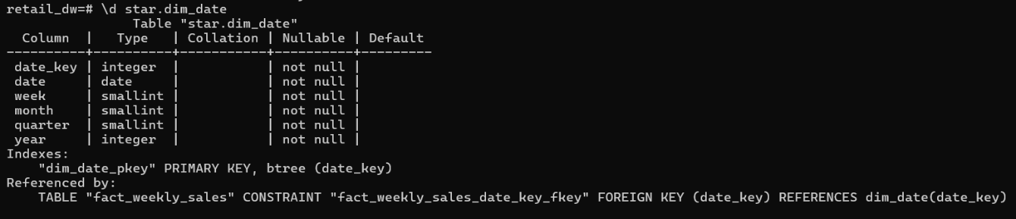

***\d star.dim_store***

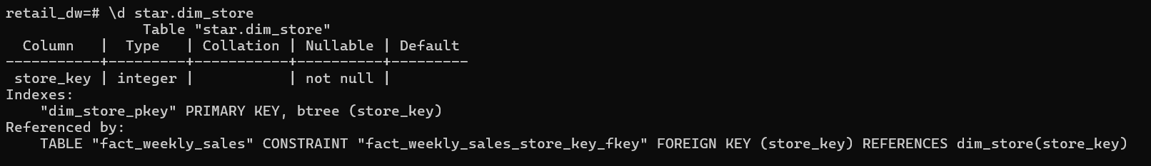

***\d star.fact_weekly_sales***

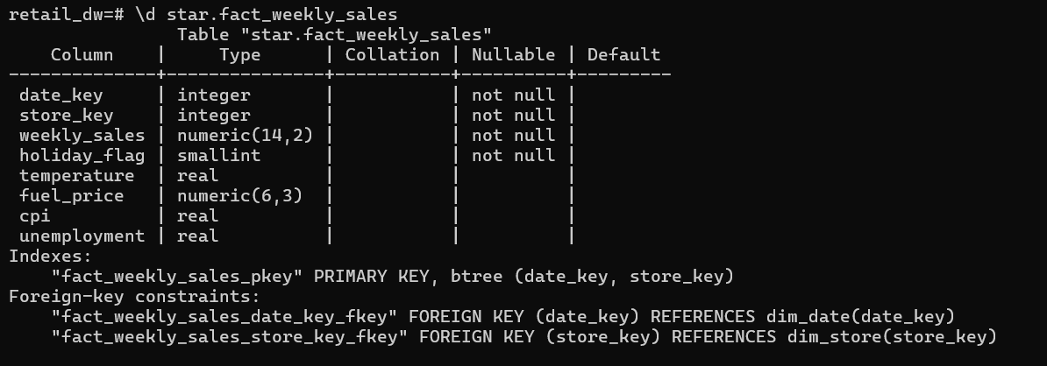

**Schema Introspection**

***SELECT table_schema, table_name***

***FROM information_schema.tables***

***WHERE table_schema = 'star';***

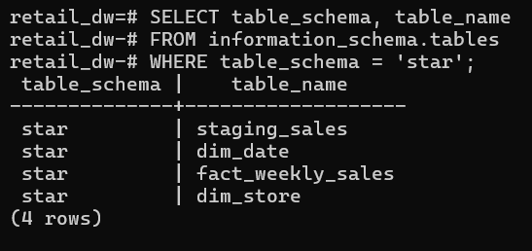

**Row Counts**

***SELECT***

***(SELECT COUNT(*) FROM star.dim_date) AS dim_date_rows,***

***(SELECT COUNT(*) FROM star.dim_store) AS dim_store_rows,***

***(SELECT COUNT(*) FROM star.fact_weekly_sales) AS fact_rows;***

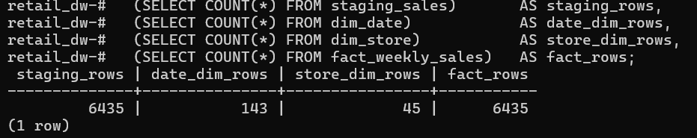

**Join Query Test**

***SELECT f.date_key, d.date, f.store_key, f.weekly_sales***

***FROM star.fact_weekly_sales f***

***JOIN star.dim_date d ON f.date_key = d.date_key***

***JOIN star.dim_store s ON f.store_key = s.store_key***

***LIMIT 5;***

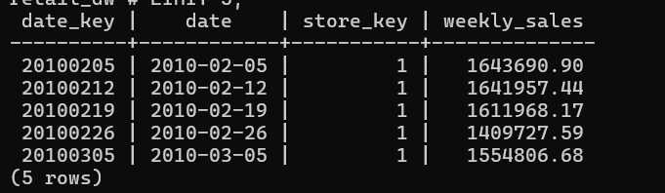

**Outcome**

* Star schema successfully implemented with normalized dimensions.
* Referential integrity established via foreign keys.
* Dataset prepared for analytical workloads, dashboards, or BI tools.